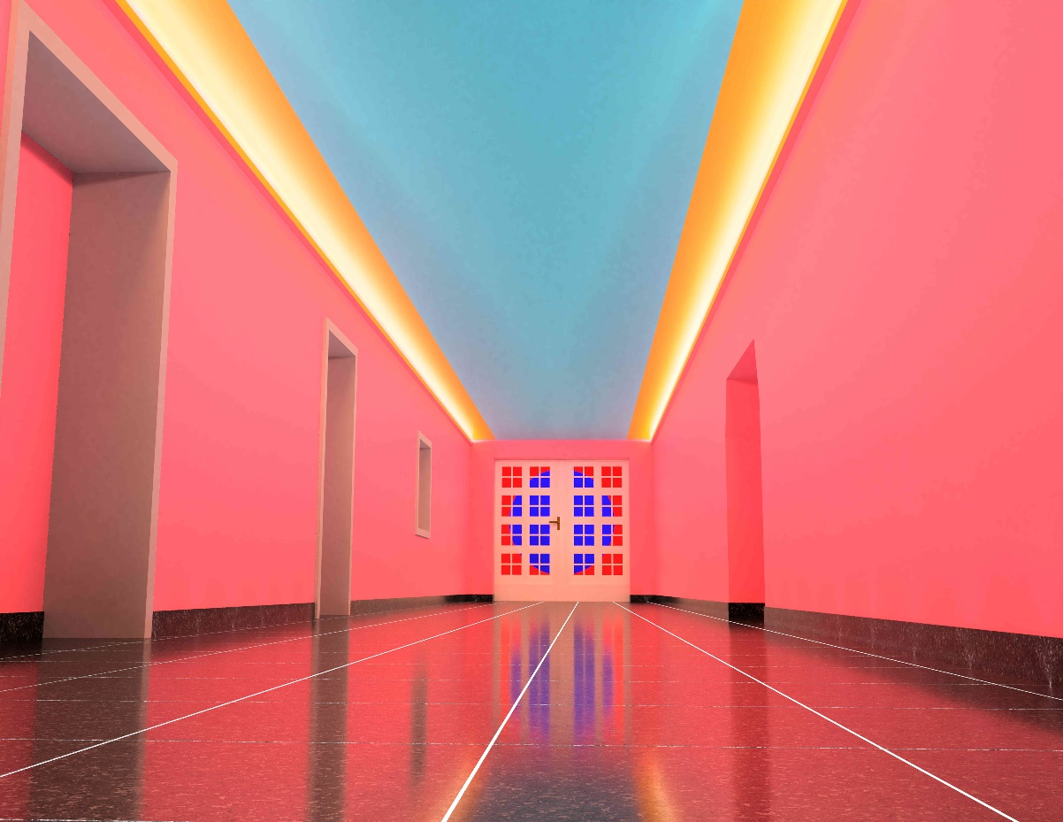

The artist **Luisa Baldhuber** (b. 1994, Munich) has created a multi-sensory, site-specific installation for the **Staff Entrance** at the rear of Haus der Kunst. **Afterglow** envelops us in the colours of a perpetually repeating sunrise and sunset. It takes up the minimalist style of the Light and Space Movement, which strongly inspired Baldhuber’s artistic work and ideas surrounding the design of the neighbouring English Garden. By integrating the illusion of a natural phenomenon into a given location through paint and light, the artist questions the original architecture of Haus der Kunst and aims to sensitise our consciousness to the things we see and, based on this, think we know.

Luisa Baldhuber enables a form of embodied experience, which unfolds over the duration of the viewing. The colour planes suggest an optical expansion of the space, reminiscent of a landscape, horizon or sky. Through the changing atmospheric colour moods created by the interplay of light and wall colours, the abstract skyscape calls to mind moments in nature and allows us to dream for a moment.

“Afterglow" takes up the minimalist style of the Light and Space Movement, which strongly inspired Baldhuber's artistic work. The movement formed on the West Coast of the USA in the 1960s (as a kind of counter-movement to the minimalism of the East Coast) and, influenced by the impressions of light and nature in California, investigated and processed the different properties of light in increasingly immersive installations. With "Afterglow", Baldhuber also takes up the ideas surrounding the design of the neighbouring English Garden and transfers them as a spatial installation to the Staff Entrance of Haus der Kunst. Despite the intended proximity to nature, an English Landscape garden is an artificially created park that is oriented towards the aesthetics of an idealised nature.

With the solo exhibitions in the Staff Entrance, Haus der Kunst is opening up a previously hidden space. The new site-specific piece of this exhibition series serves not only as an inspiration for employees during their daily commute, but also empha­sises the significance of nurturing emerging artists from Munich.

For their annual support of our programme, we thank our shareholders, the Free State of Bavaria and the Gesellschaft der Freunde der Stiftung Haus der Kunst München e. V. We also thank our major supporter, the Alexander Tutsek-Stiftung, for their generous commitment to our work, as well as the Ulli und Uwe Kai-Stiftung. We thank Erich Gassmann Architekten and Bernd Paul Sommer Elektrotechnik for their support with the realisation of the project. Curated by Anna Schneider.

**Luisa Baldhuber.**

**Afterglow  
23.2.–15.12.24**

Haus der Kunst, Staff Entrance

Prinzregentenstraße 1, 80538 Munich

Hausderkunst.de | @HausderKunst

**Press Preview: 23.2.24, 6 pm. Artisttalk during Open Haus**

**Luisa Baldhuber** (born 1994 in Munich) is currently studying at the Academy of Fine Arts Munich, where she is expected to graduate in February 2025. Her artistic interest lies in the relationship between colour, space, and light and how these influence our perception of space.